Saturated Absorption: Achieving a Continuous Scan Through Elimination of Mode Hops, Includes Implementation of Feedforward Circuit

Tyler Kellar
Advanced Projects Lab, Department of Physics, University of Oregon, Eugene, Oregon 97401
December 17, 2012

Contents
1 Saturated Absorption Spectroscopy
  - Introduction
  - Purpose
  - Setup and Procedure
1.3.1 Components and Configuration
1.3.2 Beam Evolution Through Optical Track
1.3.3 Factors Determining Laser Frequency
1.3.4 Scanning Laser's Single-Mode Frequency

2 Mode Hops
2.1 Understanding Mode Hops
  - Recognizing Mode Hops and Multi-Mode Operation

3 Eliminating Mode Hops
  - Manipulating Competing Mode Structures
  - Implementation of the Feed Forward circuit

1. Saturated Absorption Spectroscopy

1.1 Introduction
Detailed instructions for performing saturated absorption measurements are presented. Atomic transition frequencies can be precisely determined using saturated absorption spectroscopy. There are numerous Saturated Absorption setups, however, this paper will only consider the setup used for the Magneto-Optical Trap in the University of Oregon's Advanced Projects Lab. Rough schematics for this setup are provided in section 1.3. This paper will not provide instructions for constructing components provided to incoming students such as the laser control box. For complete schematics and electrical diagrams of components which are not included in this paper, see Atom Trap Project Binder, available to students in the University of Oregon's Advanced Projects Lab.

1.2 Purpose
To achieve the necessary cooling of atoms in a Magneto-Optical Trap one must induce the propagation of three orthogonally oriented pairs of overlapped single-mode laser beams. The three pairs must intersect at a central point and each individual beam must propagate in the direction antiparallel to that of its overlapping pair. The frequency of each beam must be tuned just below the F = 3 -› F' atomic transition frequency of ⁸⁵Rb. By doing so, the doppler shifts experienced by Rb atoms moving inside the trap can be exploited in order to achieve the desired cooling of the atoms'
kinetic energy.
As an atom moves inside the chamber, say to the right, it will experience a blue shift of the beam propagating in the opposite direction of its motion, from right to left, as well as a red shift of the beam propagating in the direction of its motion, from left to right. With the lasers tuned appropriately, the blue shift induced by the atom's motion increases the experienced frequency of the laser propagating to the left. This brings it closer to the ⁸⁵Rb, F = 3 → F' atomic transition frequency. The red shift of the laser propagating to the right decreases its frequency, as experienced by the atom, shifting it farther away from the ⁸⁵Rb, F = 3 → F' atomic transition frequency. Thus, the momentum imparted by the scattering of photons from the beam propagating left is much greater than the momentum imparted by the scattering of photons from the beam propagating to the right. Due to the symmetric configuration of the three orthogonal pairs of beams, the result is a velocity dependent drag force which reduces the kinetic energy of atoms with in the intersection of the beams. This arrangement of of laser fields is often referred to as “optical Molasses”. Essential to this process is the ability to accurately tune the frequency of the lasers. This can be accomplished though saturated absorption spectroscopy.

1.3 Setup and Procedure
1.3.1 Components and Configuration
Figure 1.1 Saturated Absorption Optical Path
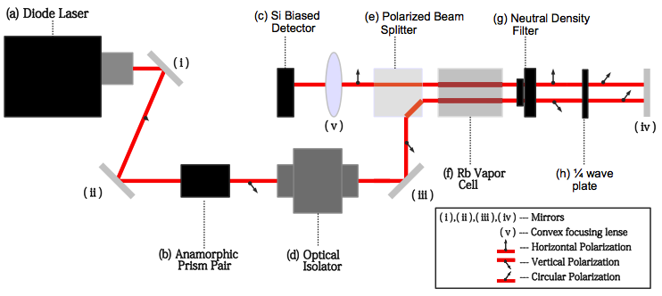
Optical Track Components:

(a) Diode Laser Box
(Boshier-Design) Emits single-mode vertically polarize beam
(b) Anamorphic Prism Pair
(2.0 x PS875) Elliptically shaped
incident beam expanded in 1-D
approaching circular shape upon
transmission
(c) Si Biased Detector
(Photo Diode Detector) Registers intensity and frequency of incident light
(d) Optical Isolator
(Conoptics M.712B) Allows for transmission of light with wavelength
λ ϵ (620nm,780nm)

(e) Polarized Beam Splitter
Refracts vertically polarized light 90°, transmits horizontally polarized light with no refraction
(f) Rb Vapor Cell
(g) Neutral Density Filter
(NEIOA Filter ND = 10) Transmits light with 1/10th attenuation of beam intensity (in one direction only)
(h) ¼ Wave Plate
(ASIX:WPL1210) Converts linear polarization to circular polarization and circular polarization to linear polarization, depending on direction of transmission

Inside the laser box, (a) in Fig. 1.1, there are three primary components, a commercial diode laser, a collimating lens and a diffraction grating. The diffraction grating is mounted so that the light diffracted into the first order returns to the diode laser. In this configuration, the diffraction grating serves as one of the end mirrors of the laser resonator cavity, while the back facet of the diode serves as the other. Throughout this paper the resonator cavity formed by these two “mirrors” will be referred to as the external cavity and the laser diode's internal resonator cavity will be referred to as the internal cavity.
The optical track outlined in this section can be used to perform saturated absorption spectroscopy over frequency ranges sufficient for the purposes of this paper. To do so, the laser should be tuned near the atomic transition frequencies of the Rb isotopes in their respective ground states. This can be achieved though simple absorption. This paper does not include information regarding simple absorption.
With the laser coarsely tuned and the optical track depicted in Fig. 1.1 appropriately configured, saturated absorption measurements can be collected by inducing a continuous periodic scan of the laser's frequency. The amplitude of the scan must be sufficient for covering the full range of atomic transition frequencies corresponding to the hyperfine ground states of ⁸⁵Rb and ⁸⁷Rb. Fig. 1.2 shows two Rb saturation spectra collected using the setup outlined in this paper. Both show doppler broadened absorption lines, each with three Lamb dips and three cross over dips, information regarding the presence and significance of both Lamb dips and cross over dips can be found in reference (2), they will not otherwise be discussed in this paper.

Figure 1.2. Saturated absorption spectrums generated using outlined setup.
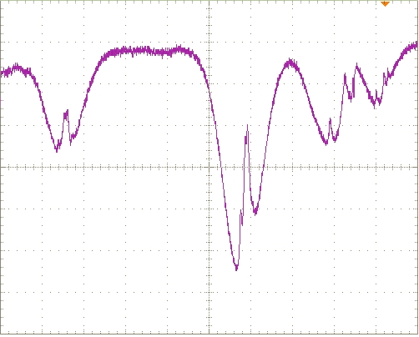
Figure 1.2a Saturation spectrum showing doppler broadened absorption lines corresponding to the three transitions ;⁸⁵Rb, F = 2 → F',⁸⁵Rb, F = 3 → F' and ⁸⁷Rb, F = 2 → F' (left to right). The far right absorption line has a minor mode hop.
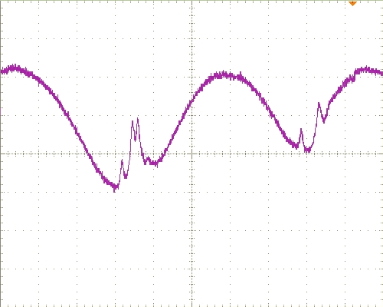
Figure 1.2b Saturation spectrum showing doppler broadened absorption lines corresponding to the ⁸⁵Rb, F = 3 → F' and ⁸⁵Rb, F = 2 → F' transitions (left to right).

1.3.2 Beam Evolution through Optical Track
Fig.1.1 (not to scale) shows the path the propagating beam emitted from the laser diode (a) follows, the components it passes through, and the polarization of the beam at various locations. It is important to note that the two beams at mirror (iv) are actually overlapped, the lower beam is incident
on mirror (iv), perpendicular to the surface. The upper beam is the reflection of that same beam propagating away from mirror (iv), antiparallel and overlapped with the incident beam.
The diode laser emits an elliptically shaped, vertically polarized beam which is reflected by mirrors (i) and (ii) into the anamorphic prism pair (b) where the transmitted beam is expanded in one dimension so that it's shape becomes circular. Next the beam enters the optical isolator (d) which transmits light of wavelength between 620 nm and 780 nm. The transmitted beam is reflected off mirror (iii) into the polarized beam splitter, which is oriented such that the vertically polarized beam is refracted 90º. After exiting the polarized beam splitter the beam passes through the Rb vapor cell (f). The beam passing through the Rb vapor cell in this direction (to the right in Fig.1.1) is called the pump beam. The pump beam then passes through the neutral density filter (g). On this setup, the neutral density filter used transmits the beam at 1/10th the intensity of the incident beam. This affect only occurs in one direction (for light incident from the left in Fig. 1.1). This is not true for the ¼ wave plate (h) the beam passes through next. The vertically polarized beam is transmitted with a 45º rotation of its polarization. After reflecting off mirror (iv) the beam passes through the ¼ wave plate (h) and is again rotated 45º resulting in transmission of the beam now horizontally polarized. Next the beam passes through the neutral density filter (g), which as stated earlier has no affect in this direction (from the right in Fig.1.1) on the transmitted beam. The beam, now with 1/10th the intensity of the pump beam and horizontal polarization, passes back through the Rb vapor cell (f), we call the beam passing through the Rb vapor cell in this direction (to the left in Fig. 1.1) the probe beam. From the vapor cell the beam is again incident upon the polarized beam splitter which transmits, the now horizontally polarized beam, with no affect through to the focusing lens (v). Lens (v)
focuses the beam into the eye of the Si biased detector (c) which collects intensity and wavelength data. The output of the Si biased detector (c) is sent to an oscilloscope plotting intensity vs. frequency measurements.

1.3.3 Factors Determining Laser Frequency
The interplay of several variable parameters determines the single mode frequency of the beam emitted from the laser box. The four primary parameters are listed below:
- External cavity length
- Laser diode gain medium
- Grating angle
- Internal cavity length
The internal temperature of the laser box also plays a role in determining the laser's frequency, however, it will be held constant and need not be considered here. Each of the four factors listed above determines either a “preferred” frequency (2
and 3) or a set of discretely spaced “preferred” frequencies (1 and 4). Each of these preferred frequencies are represented by the various peaks in Fig. 3. The point labeled emitted frequency represents a preferred frequency that each of the four factors have in common. With each parameters set appropriately, that is to have a preferred frequency in common, the laser operates with a single well-defined frequency. This is known as single-mode operation.
The medium gain is by far the most forgiving of the four factors. It will support single-mode operation over a range of frequencies much larger than the 7 GHz scan needed. Thus, it is the three remaining factors, internal cavity length, external cavity length and grating angle that will be used to tune the laser's frequency. Each of the three factors is controlled through different means. The grating angle is controlled by an adjustment screw inside the laser box and the internal cavity length is controlled by manipulating the laser diode injection current, which determines the refraction index of the gain medium. The external cavity length is controlled using a piezo-electric transducer speaker disk which expands in response to an applied voltage. With the diffraction grating mounted to the piezo disk, the application of a voltage to the piezo disk will move the grating toward the laser diode reducing the external cavity length. Altering the injection current changes the length of the internal cavity, which makes up a portion of the external cavity, thus the injection current also affects the external cavity length. However, the piezo vastly dominates control of the external cavity length.

Figure 1.3. Factors Determining the Single Mode Laser Frequency. Taken from Reference (1).
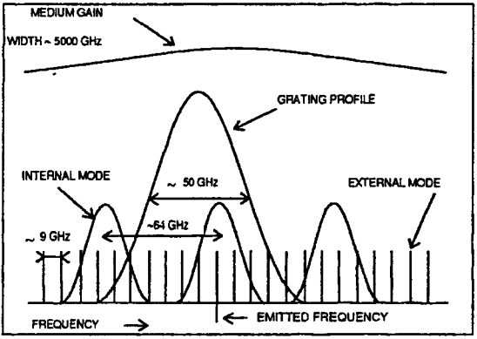
1.3.4 Scanning Laser's Single-Mode Frequency
The laser's frequency must be scanned over each of the atomic transition frequencies corresponding to the hyper-fine ground states of the ⁸⁵Rb and ⁸⁷Rb isotopes, a range of roughly 7 GHz. In order to achieve this it is not necessary to scan the grating angle or vary the internal laser box temperature. Set the grating angle using the adjustment screw and simple absorption measurements to determine the appropriate angle and hold the internal temperature of the laser box constant at 17º C.
The full 7 GHz range can be scanned by varying only the affective length of the laser's resonator cavity. This is achieved by driving a current modulated by a ramp function through the piezo disk mounted behind the diffraction grating. With a ramp function modulating the current used, the piezo chip will periodically expand and contract, as it does, the external resonator cavity length will periodically increase and decrease resulting in the desired periodic scanning of the laser's frequency.

2. Mode Hops

2.1 Understanding Mode Hops
In general, grating-tuned diode laser oscillators, the type used in the University of Oregon's Advanced Projects Lab, do not scan continuously over a sufficient range of frequencies. By scanning the piezo actuator, the collection of discretely spaced peaks in Fig. 1.3 which correspond to the various preferred frequencies determined by the external cavity shift laterally. Therefore, at several external cavity length settings, the internal and external cavities share no common preferred frequencies and attempt to set the laser at different frequencies. As a result of this internal mode competition, the laser will experience either multi-mode operation or random discontinuous jumps between different modes. These discontinuous jumps are known as mode hops.

2.2 Recognizing Mode Hops and Multi-Mode Operation
Fig. 2.1 shows two examples of saturation spectra with mode hops present. The mode hops in Fig. 2.1a are clearly visible, both appearing just to the right of the doppler-broadened absorption line corresponding to the ⁸⁵Rb, F = 2 → F' transition. Both of the discontinuous drops in probe beam intensity represent a jump from a frequency at which there is little to no interaction with the Rb atoms in the vapor cell to a frequency at which there is significant scattering. The presence of one of the mode hops in Fig. 2.1b is far more subtle. The appearance of the mode hop to the far right represents a similar jump as the two seen in Fig. 2.1a, however, the other mode hop, which likely occurs somewhere between the doppler-broadened absorption line in the middle and the doppler-broadened absorption line to the right appears for more subtly. There is no obvious discontinuous jump in the probe beam's intensity to suggest the presences of a mode hop. Only upon comparison with a mode-hop free rubidium saturation spectrum does it become apparent that a mode hop must have occurred. Nowhere in accurate rubidium saturation spectra do the three doppler-broadened absorption lines appear with the spacing seen in Fig. 2.1b. The mode hop
in Fig. 2.1b is hidden because it constitutes a jump between two frequencies with nearly equal

Figure 2.1. Saturated absorption spectrums, both with mode hops present
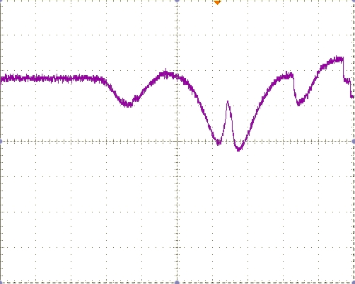
Figure 2.1a. Saturation spectrum with mode hops appearing just right of the doppler-broadened absorption line corresponding to the ⁸⁵Rb, F = 2 → F' transition
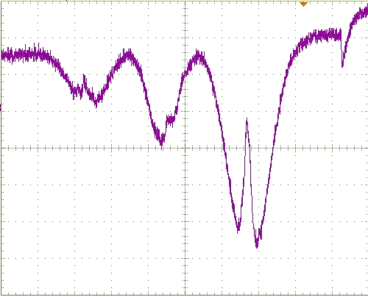
Figure 2.1b. Saturation spectrum with one mode hop likely occurring between the doppler-broadened absorption lines corresponding to the ⁸⁵Rb, F = 2 → F' and ⁸⁷Rb, F = 3 → F' transitions and another occurring to the far right of the plot

scattering coefficients. As a result, the plot of probe beam intensity appears continuous at the location of the mode hop, even though a significant discontinuous jump in beams frequency has occurred.
The occurrence of multi-mode operation is represented differently than a standard mode hop in saturation spectra. Fig. 2.2 shows a saturation spectrum in which multi-mode operation is present, evidence of which can be seen to the right of the doppler-broadened absorption line corresponding to the ⁸⁵Rb, F = 3 → F' transition. Here the laser operates at two different modes, one for which there is interaction with Rb atoms in the vapor cell, and one for which there is no interaction. As a result, in the region where multi-mode operation occurs, two different intensities corresponding to the two different modes are plotted.

Figure 2.2 Saturation Spectrum generated by laser experiencing multi-mode operation
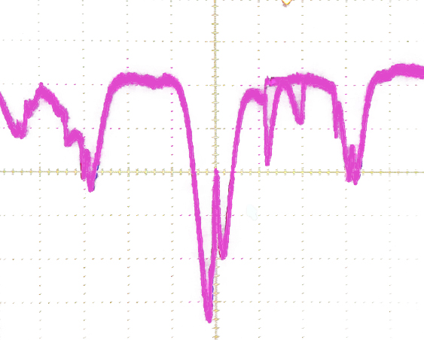

3. Eliminating Mode Hops

3.1 Manipulating Competing Mode Structures
To achieve a continuous scan of the laser's single-mode frequency across the roughly 7 GHz range needed, mode hops and multi-mode operation must be eliminated in this range of frequencies. As can be seen in Fig. 1.3, the grating angle will support single-mode operation over a range of frequencies much larger than that of the desired scan, the internal cavity, however, will not.
As the piezo actuator scans the external cavity length the corresponding peaks in Fig. 1.3 shift periodically left and right. Because the internal cavity is unaffected by the piezo's scanning, the peaks corresponding to the internal cavity remain stationary. As a result, it is impossible to scan the laser's single-mode frequency over a 7 GHz range without mode-hops or multi-mode operation occurring.
The mode-hop free tuning range can be increased by an additional modulation of the laser diode injection current using a ramp function that is simultaneously proportional to the ramp function modulating the current driving the piezo disk. This is known as the feedforward circuit. When the feedforward circuit is implemented correctly, the preferred frequencies determined by the internal cavity, represented by the corresponding peaks in Fig. 1.3, shift synchronously with peaks/frequencies determined by the external cavity. With the peaks shifting synchronously, any mode competition induced by the external and internal cavities should be eliminated. Implementation of the feedforward circuit can increase the mode-hop free tuning range to around 10 GHz, enough for the Rb spectrum.

3.2 Implementation of the Feedforward circuit
To implement the feedforward circuit, the modulated current going to the piezo must be cloned. The control box used in the University of Oregon's Advanced Projects Lab MOT project does this automatically through a tap into the PZT output on the circuit board. A bnc cable connects the PZT output to the piezo controller, carrying the modulated current driving the piezo disk's expansions and contractions. The control box also provides the means to multiply the signal by ±1, in case the polarity need be changed, as well as adjust the ratio between the piezo scan and laser diode current scan. The polarity is controlled by a switch labelled 'FAST POLARITY' and the ratio between the piezo scan and laser diode current is controlled by the trimpot labelled 'FEEDFORWARD GAIN'. The cloned signal, now altered based on the settings of these controls, is sent to the FF output. The FF output should be connected using a bnc cable to the current mod input on the current driver. As the label suggests, the laser diode injection current is modulated by the signal sent to the current mod input.
When the feedforward circuit is appropriately implemented, the ratio between piezo scan and laser diode injection current scan, the injection current and the voltage driving the piezo disk's expansions and contractions can individually controlled. Through careful tuning of these three factors, a continuous scan of the laser's single-mode frequency can be achieved over the full Rb spectrum.

References

- Toptica Photonics, Scan Control SC 100. Part VIII, 1-8. Retrieved from http://web.mit.edu/8.13/8.13d/manuals/tui-dl100-laser-system-dec01-mit-junior-lab-part-p7.pdf
- Daryl W. Preston, “Doppler-free saturated Absorption: Laser Spectroscopy, Department of Physics, California State University. (1996)
- Patrick McNicholl and Harold J. Metcalf, Synchronous cavity mode and feedback wavelength scanning in dye laser oscillators with gratings. State University of New York, Physics Department, Stony Brook, New York. 24(17), 2757-2761. (1985) Retrieved from http://george.ph.utexas.edu/~dsteck/reading/diodelasers/mcnicholl85.pdf
- K. B. MacAdam, A. Steinbach, and C. Wieman, Joint Institute for Laboratory Astrophysics and the Department of Physics, University of Colorado, Boulder, Colorado. Am. J. Phys. 60 (12). (1992)
- Carl Wieman and Gwenn Flowers, Joint Institute for Laboratory Astrophysics and the Department of Physics, University of Colorado, Boulder. Sarah Gilbert, National Institute of Standards and Technology, Boulder, Colorado. Am. J. Phys. 63 (4). (1995)

